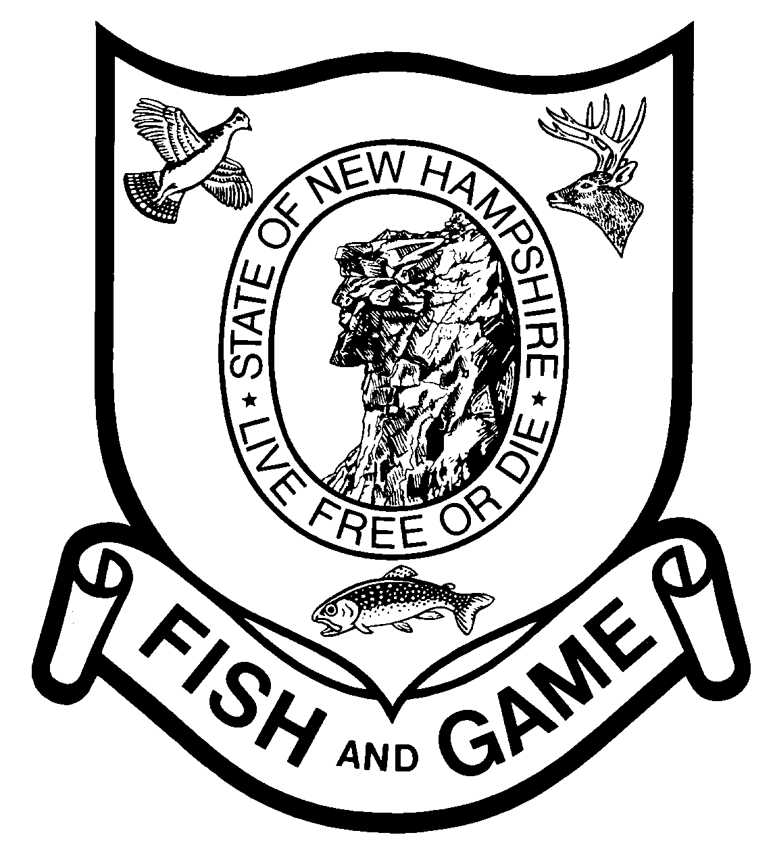

Watershed Education Program Teacher Timesheet
Name:___________________________________ School:_____________________________________
(Please Print) (Please Print)
Date  (Mm/dd/yy) | Course Activity or Description -  Enter ArcGIS, Stream Study, Trout in the Classroom, VBAP, Warm Water tank, Watershed Ecology Institute (WEI) | Hours for In Class, Field Trip, Prep time, Training | Travel  Hours | Total  Hours | Miles  Round Trip Driver Only

__________ ______
Teacher Signature (each page)
__________________________________________
Aquatic Resource Educator NHF&G Signature

When completed, please FAX or mail to:

Figure time to nearest quarter hour
1.00 = 1 hour
0.75 = ¾ hour
0.50 = ½ hour
0.25 = ¼ hour

NH Fish and Game Department, ARE Unit
11 Hazen Drive
Concord, NH 03301
(603) 271- 3212 Phone
(603) 271-0465 Fax
judy.l.tumosa@wildlife.nh.gov

